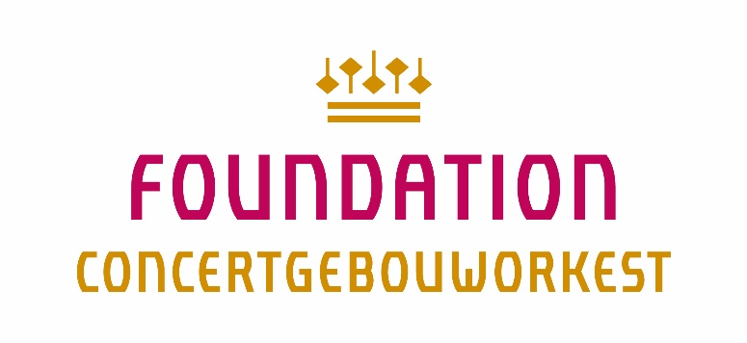

Application Form Willem Mengelberg Fonds 2022

Music students who wish to apply for the Mengelberg Fonds must fill in this entire form in Microsoft Word (do not refer to attachments or pdf files) and send it in digitally. Besides, the following documents need to be attached to this form:
- Accompanying letter in which the applicant describes the activity for which he/she requests the grant as well as his/her motivation and the intended effect on the musical development (max. 1 A4)
- Financial budget (the total costs for the activity as well as its specifications) and a financial plan (in which way are the total costs for this activity covered, e.g. other funds, own means, etc.) (max. 1 A4)
- A recent letter of recommendation written by the principal of the own educational institution or by another expert, focused on the participation in the activity for which a financial contribution is asked.
- A link to an audio recording on which the student can be heard.

Personal information

Name:
Date of Birth:
Address:
Zip Code and city:
Phone number:
E-mail:
Bank account number (IBAN):
Former applications to the Mengelberg Fonds (yes/no):

Educational background

Instrument/voice/conductor/ composition student:
Conservatory:
Main subject teacher:
Phase of study (bachelor/master/master completed):

Activity for which the contribution is requested

Name of the activity (masterclass, course, training program etc.):
Period (start and end date):
Teacher(s) which will be involved in the activity:
Short description of the activity:
Motivation for participation (effect on the musical development):
Letter of recommendation by (name and function):

Budget and financial plan

Total costs for the activity:
Specifications of the total costs: please indicate of what the total costs consists of (tuition fees, travelling costs, subsistence costs, etc.):
Own financial contribution to the activity :
Contributions by other funds (please indicate which other funds and amounts are requested as well as their status: honored, refused or pending):
The to the Mengelberg Fonds requested amount (max. €1.500,--):

Applications should be in the possession of the secretary of the Willem Mengelberg Fonds no later than May 10, 2022. Applications are being evaluated once a year in May. The applicant is eligible for a contribution from the Willem Mengelberg Fonds a maximum of 2 times. Students who applicate for the first time will be given priority. The applicant provides the secretary with a short report, including photos, after the completion of the activity.

Secretariaat Willem Mengelberg Fonds
Foundation Concertgebouworkest
020-3051010

Lili Schutte
l.schutte@concertgebouworkest.nl

www.concertgebouworkest.nl/mengelbergfonds

